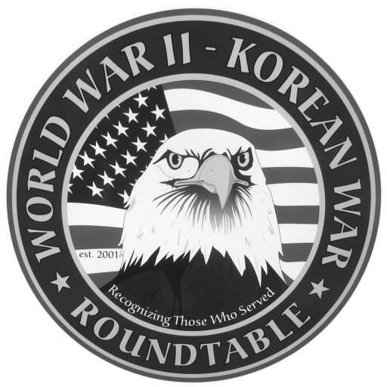 | Fairlawn Kiwanis Community Center - 3486 S. Smith Rd (off Market St.)  Fairlawn, OH 44333 - (across from City Hall and the Fire Station)

: January 28, 2010, THURSDAY, 6:45 P.M. (The 4th Thursday)

SPEAKER: Kenneth Koller, Navigator-bombardier 13th Air Force, Pacific ; 4 battle stars

November Meeting Summary: Robert L. Sabetay 3rd Army, 90th Infantry Division spoke about his numerous experiences in N. France, Ardennes & Rhineland as a combat infantryman. He started out in the artillery but was transferred to the infantry. In one incident in Germany he recalled he had 2 badly frightened teen age German soldiers in the sights of his rifle and he could not fire.

E-MAIL ADDRESSES: If you have an E-Mail address and wish to receive the meeting notices via E-Mail please contact Dean Smith (330 835 9895) or Ed Bollinger (330 836 6272 or.ehbollinger@netzero.net). If you change your E-mail address contact Ed.
DUES: Dues for September ’09 to August 2010 are $15 Please send them to Dan Demko at 1627 S. Cleveland Massillon Rd.. Copley, OH 44321
SPEAKERS FOR 2009: Mrs Jerri Donohue is our official “speakers” recruiter. Call Jerri at 440 546 1207 to volunteer yourself or to recommend others.
FUTURE SPEAKERS.
February 25, 2010 : Col Speed Wilson, Marine combat pilot in WWII (Pacific),
Korea & Viet Nam
Recommended books:
“A Time For Trumpets” (battle of the bulge) copies are at Akron Public Library
“He Rode Up Front For Patton” by Brig Gen Albin F. Irzyk (relief of Bastogne)
Roger Nelson will give a copy to the Akron Public Library.

Please complete the following and return the form with your payment to Dan Demko,
Treasurer, 1627 S. Cleveland Massillon Rd., Copley, OH 44321. Checks should be
payable to the World War II – Korean War Roundtable.

NAME:_________________________________________________________________

ADDRESS:_____________________________________ _________________ ______
Street City Zip
TELEPHONE NO. _____________________ E-MAIL_________________________
If you are a new applicant, please complete the following:

Service Branch_________________ WWII_____ Korea_____ Other____________
Do you wish to be called by the telephone committee? YES ___ or NO ___

