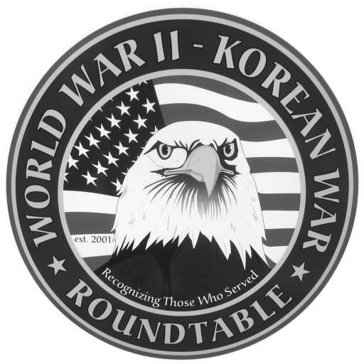 | Fairlawn Kiwanis Community Center - 3486 S. Smith Rd (off Market St.)  Fairlawn, OH 44333 - (across from City Hall and the Fire Station)

: June 24, 2010, THURSDAY, 6:45 P.M. (The 4th Thursday)

SPEAKER: Dr. Sin Mariano ; Life in the Philippines during WWII
The public is invited to attend. It is free. There is no charge to attend.
May Meeting Summary: Kent State Prof Herbert Hochhauser, Holocaust survivor and Nazi hunter: He named many German companies and physicians that were involved in the extermination of jews, gypsies, and persons with mental and physical defects and yet who retained their high status position after the war. He belonged to a group that was dedicated to reveal them. He was oftened sickend by what he found but was buoyed by the thought that “ those who survived have an obligation to speak for those who can’t”
E-MAIL ADDRESSES: If you have an E-Mail address and wish to receive the meeting notices via E-Mail please contact Dean Smith (330 835 9895) or Ed Bollinger (330 836 6272 or.ehbollinger@netzero.net). If you change your E-mail address contact Ed.
DUES: Dues for May 2010 to August 2010 are $12 Please send them to Dan Demko at 1627 S. Cleveland Massillon Rd.. Copley, OH 44321
SPEAKERS FOR 2010: Mrs Jerri Donohue is our official “speakers” recruiter. Call Jerri at 440 546 1207 to volunteer yourself or to recommend others..
FUTURE SPEAKERS.
July 22: Bernard Fishman ; London during the blitz and his experience in the
British army
LIVING HISTORY EVENT: Reenactors of German units will perform on June 5 in Mogadore. Details from Thomas Young at kartenzeichner1941@hotmail com
VIDEO TAPE PRICE REDUCTION
All of our meetings are video taped by Dick Sutherland. You can buy one for $10
or rent one with a refundable deposit of $10. Call Dick (330 666 5954) and he
will have the tape you want at the following meeting. An updated catalog of all
the tapes will be is available.

Please complete the following and return the form with your payment to Dan Demko,
Treasurer, 1627 S. Cleveland Massillon Rd., Copley, OH 44321. Checks should be
payable to the World War II – Korean War Roundtable.

NAME:_________________________________________________________________

ADDRESS:_____________________________________ _________________ ______
Street City Zip
TELEPHONE NO. _____________________ E-MAIL_________________________
If you are a new applicant, please complete the following:
Service Branch_________________ WWII_____ Korea_____ Other____________
Do you wish to be called by the telephone committee? YES ___ or NO ___

