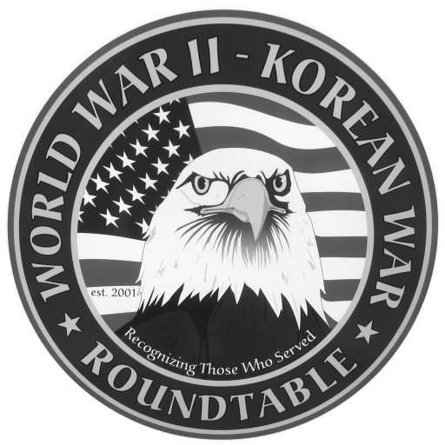 | Fairlawn Kiwanis Community Center - 3486 S. Smith Rd (off Market St.)  Fairlawn, OH 44333 - (across from City Hall and the Fire Station)

: February 24, 2011, THURSDAY, 6:45 P.M. (The 4th Thursday)

SPEAKER: Edward Fink served on the heavy cruiser USS San Francisco
during the invasions of Okinawa and Iwo Jima

JANUARY MEETING SUMMARY: Ed Miklovic , 42nd Rainbow Division, was
captured in the German counterattack in Alsace in January 1945 . His lightly armed unit
was no match against the Tiger tanks with their 128 mm gun. After interrogation he was
sent to Stalag 11B, a POW camp in N. Germany where he had a thin sheet for a blanket
and shared a bunk. The camp had a large group of Slavic prisoners and he was the
designated “trader” for his group with the other prisoners since he could speak their
language. Cigarettes were the common medium of exchange. Attendance was 68.

SPEAKERS FOR 2011: Jerry Donohue , our official “speakers” recruiter, announced that the
speakers for the next 3 months are:
March 23 . John Marinchek, President Korean War Veterans Assoc ; 18 months in Korea
April 27, Joe Huber, Filipino Guerilla group that helped his family
May 25, Hal Allen, WWII infantryman

An Extra (mostly social) meeting of the Roundtable is scheduled for Wed, Feb 9 at Papa Joe’s restaurant 1561 Akron Peninsula Rd at 11:30 AM. Call Dean Smith (330 835 9895) for reservations.

E-MAIL ADDRESSES: If you have an E-Mail address and wish to receive the meeting notices via E-Mail please contact Dean Smith (330 835 9895) or Ed Bollinger (330 836 6272 or.ehbollinger@netzero.net). If you change your E-mail address contact Ed.
VIDEO TAPES of our past presentations are available on video tape from Dick Sutherland. You can buy one for $10 or rent one with a refundable
deposit of $10. Call Dick (330 666 5954) and he will have the tape you want at the
following meeting. An updated catalog of all the tapes will be available.
DUES: Dues for September 2010 to August 2011 are $15. Please complete the following and
return the form with your payment to Dan Demko, Treasurer, 1627 S. Cleveland Massillon Rd.,
Copley, OH 44321. Checks should be payable to the World War II – Korean War Roundtable

NAME:_________________________________________________________________

ADDRESS:_____________________________________ _________________ ______
Street City Zip
TELEPHONE NO. _____________________ E-MAIL_________________________
If you are a new applicant, please complete the following:
Service Branch_________________ WWII_____ Korea_____ Other____________
Do you wish to be called by the telephone committee? YES ___ or NO ___

