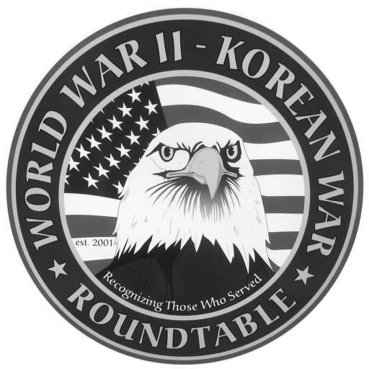 | Fairlawn Kiwanis Community Center - 3486 S. Smith Rd (off Market St.)  Fairlawn, OH 44333 - (across from City Hall and the Fire Station)

: June 23, 2011, THURSDAY, 6:45 P.M. (The 4th Thursday)

SPEAKER: Warren Miller, served in the 5th marine division at Bougainville and Iwo Jima
where he was wounded.

MAY MEETING SUMMARY: Hal Allan, WWII 87th infantry division, fought in the Saar valley ,
the battle of the bulge near Bastogne, and in Luxenbourge and cracked the Siegfried Line.
During the Bulge the cold weather was a big problem with trench foot and frost bite being
common. Food was scarce. He made his presentation wearing his old army jacket
Attendance was 77.

SPEAKERS FOR 2011:
July 28, Don Wight, served with the navy aboard the USS Bemadou for 3 invasions of Europe

The next Extra (mostly social) meeting of the Roundtable is scheduled for Wed, June 8 at Papa Joe’s restaurant 1561 Akron Peninsula Rd at 11:30 AM . Call Dean Smith (330 835 9895) for reservations.

NEW SOUND SYSTEM was installed by the City of Fairlawn. Everyone can hear now. No complaints.

Roundtable 10th Anniversary : will held on Saturday, Oct 22, at the Fairlawn Kiwanis
Center. Uniform of the day includes any parts of your old uniform that still fit.
Friends and family are welcome. A special program of interest to veterans has been
arranged. More details will be given in future newsletters as they become available.

E-MAIL ADDRESSES: If you have an E-Mail address and wish to receive the meeting notices via E-Mail please contact Dean Smith (330 835 9895) or Ed Bollinger (330 836 6272 or.ehbollinger@netzero.net). If you change your E-mail address contact Ed.

VIDEO TAPES of our past presentations are available on video tape from Dick Sutherland. You can buy one for $10 or rent one with a refundable deposit of $10. Call Dick (330 666 5954) and he will have the tape you want at the following meeting. An updated catalog of all the tapes will be available.

