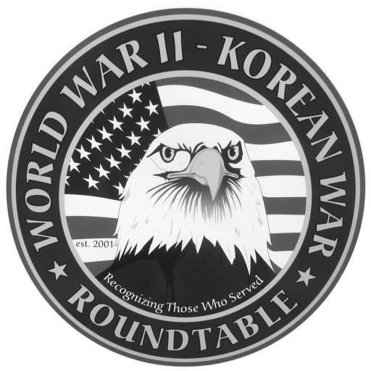 | Fairlawn Kiwanis Community Center - 3486 S. Smith Rd (off Market St.)  Fairlawn, OH 44333 - (across from City Hall and the Fire Station)

: March 24, 2011, THURSDAY, 6:45 P.M. (The 4th Thursday)

SPEAKER: John Marinchek, President Korean War Veterans Assoc; 18 months in Korea

FEBRUARY MEETING SUMMARY: Edward Fink served on the heavy cruiser USS San
Francisco as a gunnery spotter during the invasions of Okinawa and Iwo Jima. In 1944 he
informed guerrilla groups in Luzon that the Japanese were defeated. He also noted that a
great number of Navy casualties in sea battles were due to friendly fire. Attendance was 50.

SPEAKERS FOR 2011:
April 28, Joe Huber, Filipino Guerilla group that helped his family
May 26, Hal Allan, WWII infantryman

An Extra (mostly social) meeting of the Roundtable is scheduled for Wed, Mar 9 at Papa Joe’s restaurant 1561 Akron Peninsula Rd at 11:30 AM. Call Dean Smith (330 835 9895) for reservations.
Another social meeting is scheduled for Wed, April 9 also at Papa Joe’s.

Ohio Tax Info : If you reported any Military Retirement Income in 2010 on your 2010 Federal
Income Tax Form you can deduct it from your Ohio taxable income on line 45g. The same
thing is true for an Military Retirement Income you reported in 2008 and 2009 on your federal
tax report but did not deduct on your Ohio report. You will have to submit an amended Ohio
return for those years to get a refund from Ohio. The refund would amount to 4 – 5 % of your
reported Military Retirement Income.

E-MAIL ADDRESSES: If you have an E-Mail address and wish to receive the meeting notices via E-Mail please contact Dean Smith (330 835 9895) or Ed Bollinger (330 836 6272 or.ehbollinger@netzero.net). If you change your E-mail address contact Ed.

VIDEO TAPES of our past presentations are available on video tape from Dick Sutherland. You can buy one for $10 or rent one with a refundable deposit of $10. Call Dick (330 666 5954) and he will have the tape you want at the following meeting. An updated catalog of all the tapes will be available.

