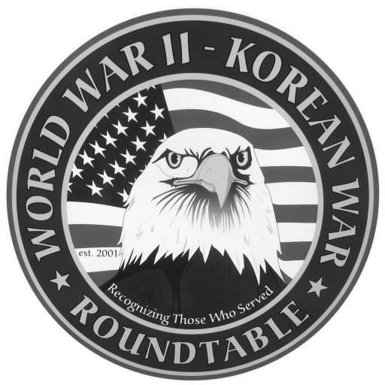 | Fairlawn Kiwanis Community Center - 3486 S. Smith Rd (off Market St.)  Fairlawn, OH 44333 - (across from City Hall and the Fire Station)
NEXT MEETING MARCH 22: Major General Donald Jenkins, a bomber pilot
during the Korean War , will discuss the US Airforce before and during the
Korean War

FEBRUARY MEETING SUMMARY. Thomasz Wyszynski, served with the Polish army
And air force as part of the fighter aircraft maintenance crew in the battle of Britain.
His odyssey from Poland at the beginning of WWII to its end in England
took him through 2 years in Siberia, then Iran, Iraq, South Africa , London & New
York Attendance was 83

FUTURE SPEAKER
April 26 : Dick Young, served with the 5th Marine regiment and the Marine Air Wing
during the Korean War

RIDES TO ROUNDTABLE MEETINGS: If you need transportation to our meetings , or if
you are willing to provide transportation please call Dean Smith (330 835 9895)

E-MAIL ADDRESSES: If you have an E-Mail address and wish to receive the meeting notices via E-Mail please contact Dean Smith (330 835 9895) or Ed Bollinger (330 836 6272 or ehbollinger@netzero.net). If you change your E-mail address contact Ed.

VIDEO TAPES of our past presentations are available on video tape from Dick Sutherland. You can buy one for $10 or rent one with a refundable deposit of $10. Call Dick (330 666 5954) and he will have the tape you want at the following meeting. An updated catalog of all the tapes will be available. The presentations are also now available on disc for purchase only. The price is $20.

Roundtable Contacts:

David Post 330 668 2447 President
Dean Smith 330 835 9895 Secretary and Speaker Recruiter
Dan Demko 330 666 2502 Treasurer
Dick Sutherland 330 666 5954 Videos of past meetings
Ed Bollinger 330 836 6272 E-mail meeting notice

